**Schematic Analysis Report**

**Overview**

* **Project Title:** hello_world_arty
* **Device:** xc7a100tcsg324-11
* **Design File:** hello_world.vhd
* **Synthesis Status:** Completed
* **Implementation Status:** Completed

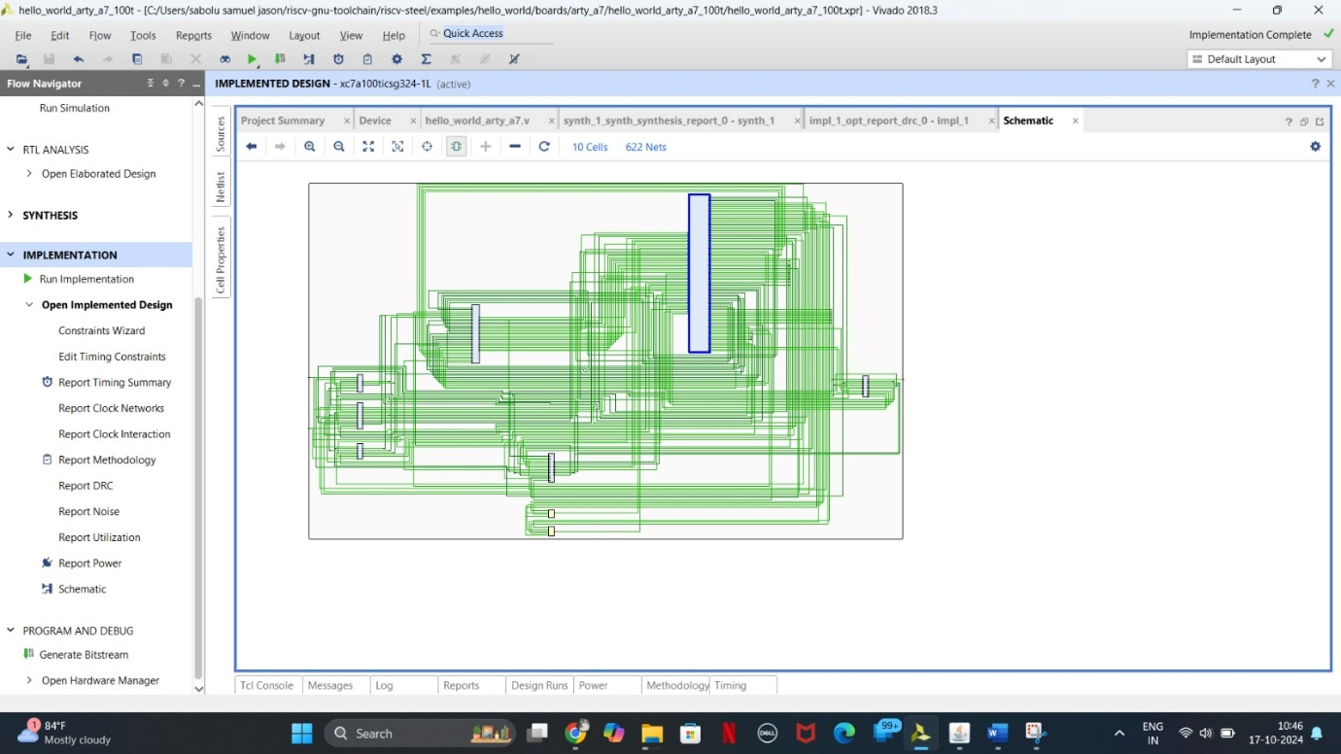

**Schematic Analysis**

The schematic appears to be a simple design, likely a basic "Hello, World!" implementation for an Arty A7 FPGA board. While the specific details of the design are not entirely clear from the image, we can make some general observations:

* **Top-Level Block:** The design appears to have a single top-level block.
* **Interconnections:** The schematic shows a network of interconnected components, including logic gates, flip-flops, and possibly other elements.
* **Input/Output Pins:** The design likely includes input and output pins for communicating with the FPGA board.

**Potential Areas for Analysis**

* **Signal Flow:** Analyze the signal flow to understand how data moves through the design and ensure that the logic is correct.
* **Timing Analysis:** Verify that the design meets the timing requirements specified by the FPGA device.
* **Power Consumption:** Estimate the power consumption of the design to ensure it stays within the specified power limits.
* **Design Rules Checks (DRC):** Run DRC to identify any potential design rule violations that could affect the functionality or manufacturability of the design.
* **Layout and Routing:** If the design has been implemented, analyze the layout and routing to ensure that the physical implementation meets the design intent.

**Additional Considerations:**

* **Documentation:** Ensure that the design is well-documented, including a clear description of the functionality, inputs, outputs, and internal logic.
* **Testing:** Develop test cases to verify the correctness of the design and to identify any potential bugs or issues.
* **Optimization:** If necessary, optimize the design for performance, power consumption, or area.